Source : https://efcms.engr.utk.edu/ef105-2021-01/grav/labs/optimization-1/experience-solver-optimization

Optimization is the process of finding a solution to a problem that results in the "best" performance, where "best" is usually defined in terms of maximizing or minimizing some value related to the function.

**Example**

Create a blank worksheet named "Optimize Cylinder". You are asked to design a cylindrical can that holds *12oz* with a minimum heat loss. Since heat loss is proportional to the surface area, you need to minimize the surface area. You can solve this [analytically with a little calculus](https://efcms.engr.utk.edu/ef105-2021-01/grav/labs/optimization-1/images/solver-minsurfarea-eq.png) or you can use Excel's solver.

* Surface area of a cylinder = top + bottom + side = *πr*2+*πr*2+2*πrh*

• Volume of a cylinder = *πr*2*h*

* Use the function PI() for π in Excel.
* Units need to match. Use a formula and let Excel convert 12[ounces to cubic inches](http://www.google.com/search?q=how%2Bmany%2Bcubic%2Binches%2Bin%2Ban%2Bounce).
* Minimize surface area equation
* Height and radius are the variables that can change
  + height and radius are both lengths, so must be greater than 0
* Volume = target_vol_cubic_inch is a constraint
* **Answer:** radius=1.5 in, height=3 in

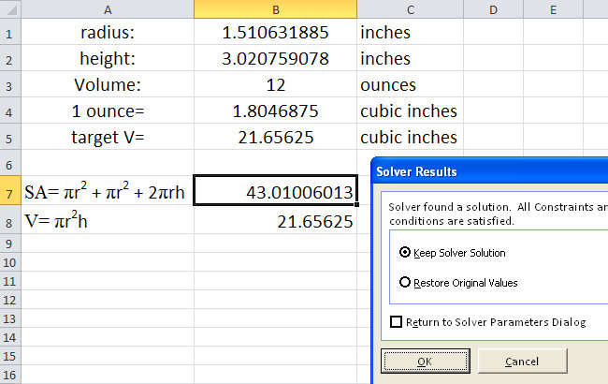

* Parameters, intermediate values, objective values, and constraint values all must be linked through formulas. Check that changing parameters properly updates other values that the solver will use.
* I used the "Make unconstrained variables non-negative" option to indicate that the radius and height must be non-negative. If you do not have this option you should add two additional constraints.

**Initial Values and Feasible Solutions**

If solver can not find a feasible solution it will tell you so. If that occurs double check that all your formulae are correct and try adjusting the initial values of the parameters.

* Use sensible starting values for your parameters, e.g. if the parameters represent physical lengths set them to a positive non-zero value.